Document Number: | GYS/EXD/OSS/0001
Document Title: | Highways Agency HLD WP190 IPT - Circee and IAMS
Document Type: | High Level Design

2 | 17/02/12 |  | Updated after face to face workshop | BO
1 | 08/02/12 |  | First Submission in Fluor Template | BO
REV | DATE | PAGE QTY | DESCRIPTION | AUTH | SPONS | GeneSYS | HA Consent
REVISION |  |  |  | APPROVALS |  | ACCEPTED

FUTURE PLANNED REVISIONS

Planned Amendment | Reason for Amendment | Planned date for next revision

Brief Description of Document:
[Write a brief description of the document. Include its intended audience. Highlight key words in bold. These will be used for searching]

This document presents the high level design for the OSS solution in support of the IPT deployment.

Date Initiated: |  | Due date to CDCG for Lead Review: | [Ask Fluor sponsor for due date]

Record of Internal Revision
Use this Record of Revision to record all internal revisions (with decimals: 01.1, 03.2 etc.) prior to submission. Only when a document is due to the HA is the main revision sheet on the front page of the main document used (with whole numbers: 01, 02 etc.)

This is to be completed by all reviewers/approvers/authors of document. If a document is “approved” type “APPROVED” in the Review Comments.

Revision | Date | Name | Review Comments | Project Control Check
0.1 | 19/01/12 | Bode Oluwasanmi | Initial Revision
0.2 | 30/01/12 | Bode Oluwasanmi | Updated after addressing Circee requirements from Fluor
0.3 | 02/02/12 | Bode Oluwasanmi | Updated for Netcool IAMS
0.4 | 04/02/12 | Bode Oluwasanmi | Updated after Peer review
0.5 | 07/02/12 | Bode Oluwasanmi | Updated after internal ALU review
0.6 | 08/02/12 | Bode Oluwasanmi | Updated after Peer review
1.0 | 08/02/12 | Bode Oluwasanmi | Packaged for issue
1.1 | 13/02/12 | Bode Oluwasanmi | Added a table with the enriched fields
1.2 | 17/02/12 | Bode Oluwasanmi | Updated after face to face review with Fluor and HA
1.3 | 21/02/12 | Bode Oluwasanmi | Added the official document number
CONTENTS
CONTENTS 4
LIST OF FIGURES 6
LIST OF TABLES 7
ABBREVIATIONS 8
OBJECTIVES 9
1 Section 1: Introduction 11
1.1 Purpose & Scope 11
1.2 Background and Business Drivers 12
1.3 Problem or Vision Statement 12
2 Service Impacts 14
2.1 Service Type 1D and 1E 14
2.2 Service Type 2D and 2E 15
3 System Architecture 18
3.1 System Functional Architecture 18
3.1.1 Functional Architecture Diagram 18
3.1.2 Description of System 19
3.1.3 Description of System Changes 19
3.2 Subsystem Functional Architectures 19
3.2.1 Netcool Functional Changes 19
3.2.2 Circee Changes 29
3.3 Data model 35
3.3.1 High Level Data Model 35
3.3.2 Data Ownership Principle 38
3.4 Use Cases 38
3.4.1 WP190_UC1: Manage Inventory Item 39
3.4.2 WP190_UC4: Manage Maintenance Profiles 45
3.4.3 WP190_UC5.1: Record Alarm 46
3.4.4 WP190_UC6: Display Alarm 48
3.4.5 WP190_UC7: Enrich Alarm 49
3.4.6 WP190_UC9: Correlate Alarm 49
3.4.7 WP190_UC10: Define Alarm View 50
3.4.8 WP190_UC11: Report Performance 51
3.4.9 WP190_UC11: View Performance Report 52
3.5 Business Processes 53
3.6 Data Flow 53
3.7 Interfaces 53
3.7.1 External Interface Changes 53
3.7.2 Internal Interface Changes 53
4 Non-Functional Architecture 55
4.1 Capacity and Dimensioning 55
4.1.1 Initial Recommendations 56
4.2 Migration 57
4.3 Availability 57
4.4 Back up and Restore 57
4.5 Data Storage 57
4.6 Security 57
4.7 Reliability 57
5 Impacted Functional Specification Documents 59
6 Requirements and Solution Traceability 61
6.1 Netcool Requirements Mapping 61
6.2 Circee Requirements Mapping 66
7 Low Level Design Part 1 71
7.1 Netcool Alarm Formatting 71
7.2 Netcool Alarm Enrichment 72

LIST OF FIGURES
Figure 1 - Service Types 1 D and E 15
Figure 2 - Service Type 2 D and E 16
Figure 3 - NRTS OSS Architecture 18
Figure 4 - Netcool Functional Diagram 20
Figure 5 - Handling of MIDAS STI Impacting Alarms 23
Figure 6 - Handling of SIGNAL STI Impacting Alarms 24
Figure 7 - Synthetic Alarm Generation 24
Figure 8 - IPTNEM Failover - Netcool Response 26
Figure 9 - High Level Migration Sequence 28
Figure 10 - High Level Processing of Migrated Transponder Alarms 29
Figure 11: Circee Component Design Changes 33
Figure 12: High Level Data Model 36
Figure 13: Use Cases 39

LIST OF TABLES

Table 1 - Background and Business Drivers 12
Table 2 - Links and References 12
Table 3 - IPTNEM Failover - Netcool Decision Table 26
Table 4 - Circee Requirement Coverage 31
Table 5- Catalogue and Templates 31
Table 6 - ATMg & IATMg 33
Table 7 - SPCA IPT 1423 34
Table 8 - TCGSA IPT 1423 34
Table 9 - TCGSA IPT 1423 DL 34
Table 10 - SPCA IPT LRS24 & ASMI52 34
Table 11 - SPCA-SPCB IPT 1423 DL & SPCA Non Adj 1423 DL 35
Table 12 - SPCB IPT ASMi52 35
Table 13 - Data Repository Changes 37
Table 14 - Data Ownership 38
Table 15 - Server Sizing Guidelines 56
Table 16 - List of Required Functional Specification Documents 59
Table 17 - Key Netcool Field Mapping 71
Table 18 - IPT Alarm Enrichment Fields 72
Table 19 - End Device Alarm Enrichment Fields 73

ABBREVIATIONS
Term/Abbreviation | Description
APTR | All Purpose Trunk Roads
HA | Highways Agency
HLD | High Level Design
IAMS | Interim Alarm Management Solution
IPT | IP Translator
IPTNEM | IP Translator Network Element Manager
NRTS | National Road Transport Systems
OSS | Operational system support
QDT | Quinton Data Team
PDAT | Performance Data Analytical Tool
PTZ | Pan, Tilt and Zoom
RMD | Roadside Multiple Diversity
SCR | Service Credits Regime
SDP | Service Delivery Point
SoR | Schedule of Requirements
SPC | Service Provision Capability
SSL | Simulation Systems Ltd.
ST | Service Type
STI | Service Type Instance
WP | Work Package
OBJECTIVES
The purpose of this document is to provide the High Level Design for the Circee and IAMS (Interim Alarm Management Solution) phases of Work Package 190 for the Highways Agency project. The document details the delta design changes that need to be made to provide a comprehensive OSS solution to manage the replacement of the legacy transponders with IP Translator devices. This represents the design for phase 1 and 2 of the IPT solution. Phase 3 will provide the full solution, including the remaining Netcool and Circee updates for basic alarm handling, and the solution for the Netcool parent/child correlation. It will also include any other changes required for the remaining OSS subsystems.

This document captures the ‘delta’ to the base service charge solution [1] and does not document the system as a whole. It will ultimately be used to update the registered Functional Specification documents and other assurance documents, as necessary.

This document describes the IPT solution for Phases 1 and 2, in terms of changes to:
- Supported Services
- System Architecture (as a whole)
- Sub-system Architectures (functional) for Netcool and Circee
- Data Model for Netcool and Circee
- Use Cases and Business Processes
- Non-functionals, including Capacity Modelling and Migration
- Functional Requirements

Unchanged system elements are described to give background and context.

The detailed design of each Subsystem described in the HLD will be provided by a Low Level Design Part 1 (LLD Part 1), which will be subsequently included as a distinct section of this document, and a Low Level Design Part 2 (LLD Part 2), which will exist as a separate document. The LLD Part 1 will provide the logical detailed design, the LLD Part 2, the physical detailed design

SECTION 1: Introduction

Section 1: Introduction

Purpose & Scope
Work Package 190 is to deliver an OSS Solution to provide management of the IP Translator device deployment into the HA/NRTS network. The OSS solution will provide functionality in line with the contractual requirements stipulated in the statement of requirements.
The scope of the project in its entirety is limited to the following OSS subsystems.
- Fault Management – Management of IPT, IPTNEM fault alarms
- Inventory – Modelling and management of IPT devices and sub-components and IPT related infrastructure and services including active, passive and civils.
- Maintenance – Modelling of IPT devices in the maintenance solution
- Trouble Ticketing – Support for the new devices and service types to be introduced as a result of the IPT deployment.
- Website – A pass through to the PDAT performance reporting system
- Performance Reporting – Removal of all legacy functionality to support Halogen performance reporting

The delivery at phases 1 and 2 of the project will deliver the bulk of the Inventory (Circee) capability and a basic alarm handling solution (a.k.a Interim Alarm Management Solution (IAMS)) within Netcool. The scope of each of the Circee and Netcool delivery aspects is enumerated below:
Netcool Scope:
- Alarm field mapping & formatting (including Severity & Summary)
- Problem/resolution event identification and processing
- De-duplication
- Fixed lookup tables (i.e. lookups with permanent/static values)
- Calculation of affected STIs + Outages
- Simple enrichment (e.g. external Asset data queries in Circee)
- Automatic trouble ticketing.
- Halogen to IPT migration rules

Circee Scope:
- Delivery of equipment templates and catalogue items
- Updates to enable enrichment of power landlord fields
- Delivery of service templates

Background and Business Drivers
Business driver | Realisation | Associated Business Requirements
Ensure that there is no increase in Operational effort to provide surveillance of the HA network. | IPT alarms will be captured and processed by Netcool. Netcool views will be created for the service affecting IPT and end device alarms which will enable the NOC to identify the pertinent alarms | BR439  BR443  BR446  BR452  BR455  BR474
Accuracy of Service Credit Regime (SCR) assignment and calculation | The identification of service affecting alarms and the enrichment of the alarms with the relevant STI information will help the NOC to accurately classify tickets as faults or outages and subsequently improve the accuracy of the Service Credit Regime | BR446
Table 2 - Background and Business Drivers
Reference | Document Name | DMS Document ID
 | GYSRGDSSP0001_R10 PS-DS036 NRTS System Architecture | GYS/RGD/SSP/0001
 | GYSRGDTSP0182_R03 IP Translator Functional Specification.doc | GYSRGDTSP0182
 | Outline Specification for WP 190 | N/A
 | GYSRGDSSP0104_R03.0 PS-DS036-200 OSS Global Data Model.doc | GYSRGDSSP0104
 | IPT Technical Specification Issue 1 GYS_RGD_TSP_0203.docx | GYS/RGD/TSP/0203
 | GYSRGDPRP0008_R12 Fault Management (PS DS010).doc | GYS/RGD/PRP/0008
 | Highways Agency Production Netcool Infrastructure Low Level Design V0.4.doc | N/A
 | HA-CIRCEE & D7i Inputs Template-IPT V1.0.xls | N/A
 | 111020 GYSEXDPRC00xx_ERCC IPT Trial Spans Changeover Management Plan-NRTS ID 04192_DRAFT.pdf
 | IPTNEM-OSS Interface Specification v03 | GYS_GRD_TSP_0228.doc
 | IPT_Alarm_List v24 | N/A
Table 3 - Links and References

Problem or Vision Statement
IP translators are to be introduced into the HA network as a replacement of the legacy transponder devices. Relevant updates to the OSS solution are required to support the deployment of the new device and associated services.

Section 2: Service Impacts

Service Impacts

The current Service Types in use with Signals and MIDAS are 1A and 2B respectively. As part of the IPT deployment, service types 1D/1E and 2D/2E will be introduced for Signals and MIDAS respectively. Service Types 1D and 2D utilise a resilient IP path to the IP-Translator, whereas Service Types 1E and 2E utilise a non-resilient IP connection between the TS and the IP-Translator.
The following descriptions of the service types are from the IPT Technical Specification Issue 1 GYS_RGD_TSP_0203 document in [4].

Service Type 1D and 1E
An Instance of Service Type 1D and 1E shall be defined as the supply, over the life of the Service Type Instance (STI), of both of the following links to a Service Delivery Point (SDP) that supports one or more NMCS2 Roadside Devices
The link is either between:
- SDP 1DE-1 – the output of the IP port associated with a Local Communications Controller (LCC) at the Control Office; and,
- SDP 1D-2 – an SDP that supports connections to the line side of the RS485 line drivers of one or more Roadside Devices, where the IP path, from SDP 1DE-1, to the associated IP Translator is via a resilient IP connection; or
- SDP 1E-2 – an SDP that supports connections to the line side of the RS485 line drivers of one or more Roadside Devices, where the IP path, from SDP 1DE-1, to the associated IP-Translator is via a non-resilient IP connection between the TS and the IP Translator.
where:
- the link between an Instance of SDP 1DE-1 and the associated IP input port to an IP-Translator shall have the transmission characteristics of the equivalent Service Type 8 variant that provides the IP connection to the IP-Translator; and,
- the link between the RS485 output port of the IP-Translator and the associated Instances of SDP 1D-2 or SDP 1E-2 shall have the transmission characteristics of a 2 wire multidrop circuit capable of supporting the RS485 standard at a data rate of 2.4kbps;
and where:
- the logical locations of SDPs are as shown in Figure 1;

The default SDP stream direction will be set in Circee as follows.

SDP 1DE-1 UP
SDP 1D-2 DOWN
SDP 1E-2 DOWN

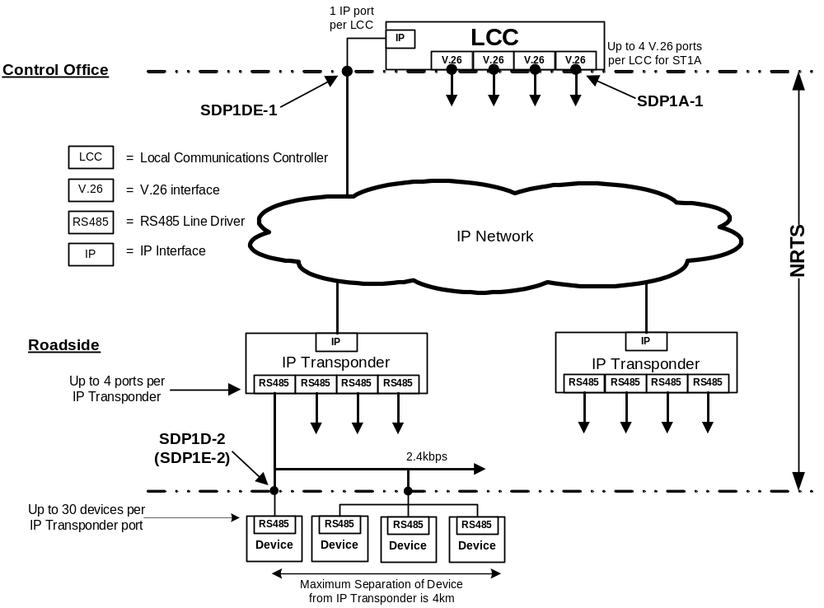

Figure 1 - Service Types 1 D and E

Service Type 2D and 2E
An Instance of Service Type 2D and 2E shall be defined as the supply, over the life of the Service Type Instance, of both of the following links to support one MIDAS Detector:
- SDP 2DE-1 – the output of the IP port associated with a MIDAS Local Communications Controller (MLCC) at the Control Office; and,
- SDP 2D-2 – the line side of the RS485 line driver in a MIDAS Detector, where the IP path, from SDP 2DE-1, to the associated IP-Translator is via a resilient IP connection; or
- SDP 2E-2 – the line side of the RS485 line driver in a MIDAS Detector, where the IP path, from SDP 2DE-1, to the associated IP-Translator is via a non-resilient IP connection between the TS and the IP Translator.
where:
- the link between an Instance of SDP 2DE-1 and the associated IP input port to an IP-Translator shall have the transmission characteristics of the equivalent Service Type 8 variant that provides the IP connection to the IP-Translator; and,
- the link between the RS485 output port of the IP-Translator and the associated Instances of SDP 2D-2 or SDP 2E-2 shall have the transmission characteristics of a 2 wire multidrop circuit capable of supporting the RS485 standard at a data rate of 4.8kbps;
and where:
- the logical locations of SDPs are as shown in Figure 2 ;

The default SDP stream direction will be set in Circee as follows.

SDP 2DE-1 UP
SDP 2D-2 DOWN
SDP 2E-2 DOWN

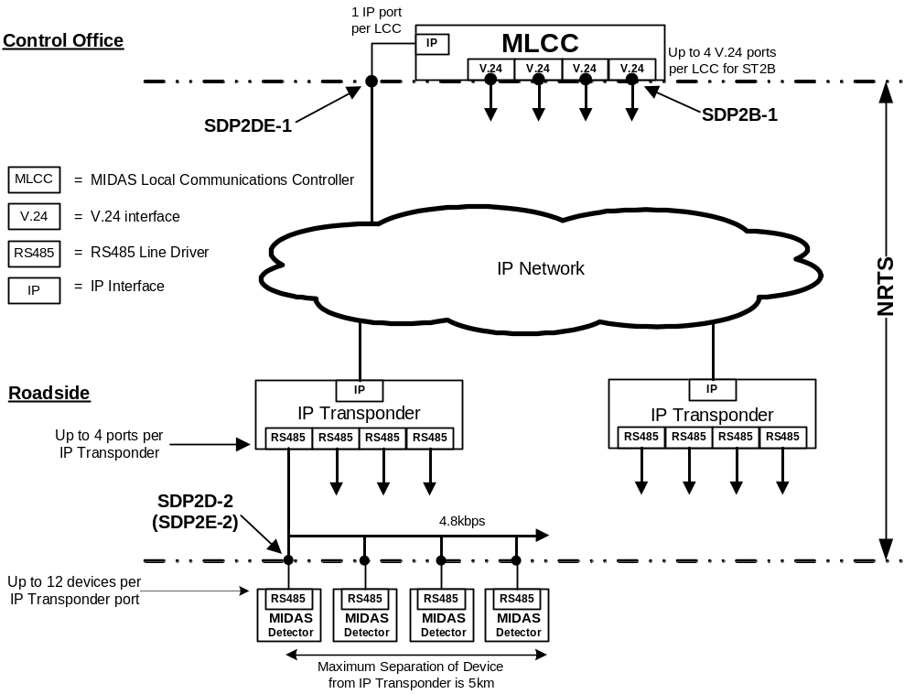

Figure 2 - Service Type 2 D and E

Section 3: System Architecture

System Architecture

System Functional Architecture

While there will be no change to the functional architecture of the overall OSS solution, some of the subsystems will be impacted. Section 3.1.1 below shows the functional architecture and interfaces involved in phases 1 and 2 of the end-to-end OSS solution. It also shows the subsystems that will be impacted by this work pack and their set of capabilities extended in support of IPT.

In addition to the impacted OSS subsystems, a new element manager (IPTNEM) will be introduced into the network to manage the IPT devices. This element manager is shown in the diagram below.

Functional Architecture Diagram
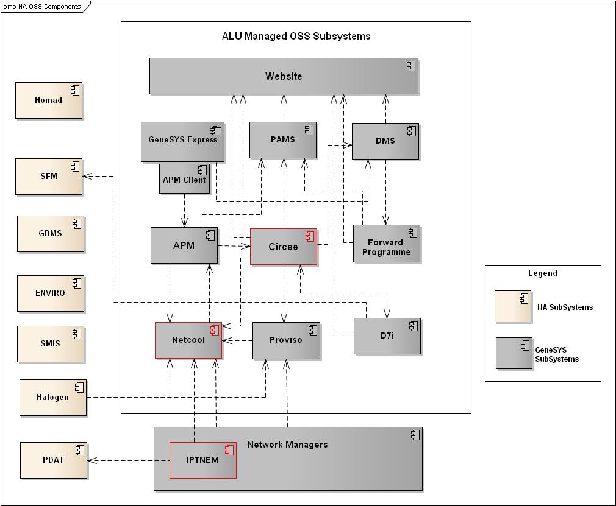
Figure 3 - NRTS OSS Architecture

Description of System
The composition of the NRTS OSS is as illustrated above in Error: Reference source not found. The PDAT performance monitoring tool which is being introduced to monitor the IPT devices is out of scope for phases 1 and s work package.

Description of System Changes
Fundamentally, the OSS architecture will not be changed as a result of this work package. The IPTNEM will be introduced as a new source of alarms for monitoring of the IPT devices but the IPTNEM is seen as an element manager and sits in the Network layer of the solution.

Subsystem Functional Architectures

Netcool Functional Changes
The functional changes to Netcool are identified by the objects in the red outline in Figure 4.
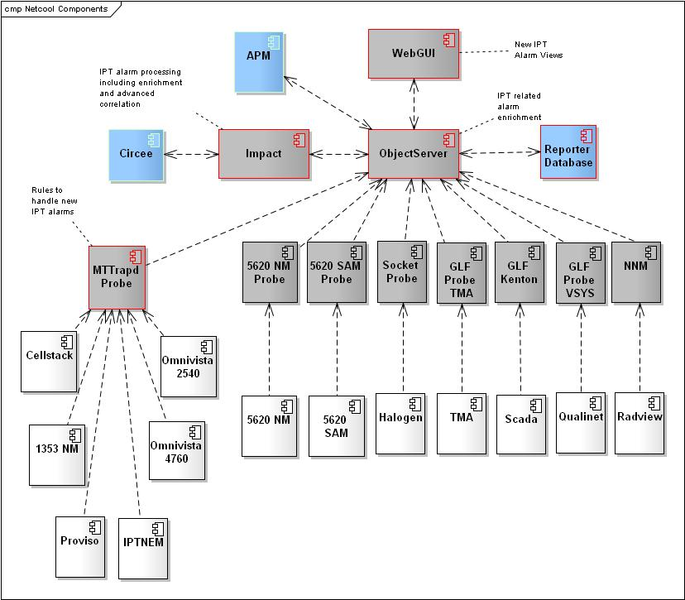

Figure 4 - Netcool Functional Diagram
To provide the fault management capability in line with the SoR and the IPT project specific requirements, the following changes will be made to the Netcool deployment. A number of new alarms will be introduced as a result of the IPT deployment. These alarms are documented

Alarm Capture and Handling

- The Netcool SNMP Probe (MTTRAPD) rules and lookup files will be updated to ensure events from IPTNEM are captured, formatted and processed as required. The IPT event details will be mapped into the appropriate fields in Netcool.

- The IPT alarm list details all the traps that will be generated from the IPTNEM. The alarm list also contains of the attributes which will be contained in the traps. A full list of trap details can be found in the IPTNEM to OSS interface specification document [9].

- The Netcool SNMP probe will be updated to ensure that event de-duplication and alarm clearing processing for IPT device alarms is fully supported. The managed object names of the alarming components will be used as one of the fields to uniquely identify the alarms and will support alarm de-duplication.

- The problem and corresponding resolution alarms will be identified in the alarm list. Where resolution alarms are not identified, appropriate expiry times will be set for the alarms.

- The lookup table which sets the status of an alarm as service or resilience affecting will be updated. The input for this table will be from the information in the alarm list.

- A lookup table relating end devices and IPT TCP ports will be used by the probe to enrich end device alarms. When an end device alarm is received, the lookup will provide the corresponding IPT TCP Port. The table below shows the mapping for the MIDAS devices.

Electronic Address (Key Field Used for Lookup) | TCP/UDP Port
000 | 10800
001 | 10801
002 | 10802
003 | 10803
004 | 10804
005 | 10805
006 | 10806
007 | 10807
010 | 10808
011 | 10809
012 | 10810
To
176 | 10926

The table below will be used for the Signal device port to electronic address mapping
Electronic Address  (Key Field) | TCP/UDP Port
000 | 10500
001 | 10501
002 | 10502
003 | 10503
004 | 10504
005 | 10505
006 | 10506
007 | 10507
010 | 10508
011 | 10509
012 | 10510
To
376 | 10754

- The reporter database will be updated to include the new power landlord and TCP Port fields.

Alarm Enrichment

- The Netcool Impact transponder enrichment policy will be updated to support the new IPT alarms where required. The service affecting IPT alarms will be enriched with STI impact details. This will include enriching service affecting IPT alarms with the number of connected end devices and the SDP location.

- The existing end device enrichment policy will be updated to support the new end device alarms from the IPTNEM. Alarms will be enriched with data including but not limited to the following.

  - Source IPT Geographic Address
  - SDP Location
  - Affected STI

- An automation will be created in Netcool to notify the NOC when no alarm has been received from the IPTNEM within a set period.

- Synthetic service affecting alarms (see section 3.2.1.3) will be enriched with the details of the affected STIs including the STI Ids and the number of affected STIs.

Synthetic Alarm Generation
This subsection describes the creation of synthetic service affecting alarms
An impact policy will be created to handle impacted STI notifications. For MIDAS devices, there is a one to one mapping between end devices and STIs. As such, MIDAS end device alarms will be treated as STI impacting alarms. These alarms will be enriched with the STI reference and the Serials of the underlying end device alarms and filtered into the impacted STI alarm view. This is depicted in Figure 5.

For Signalling devices, there is potentially a many to one relationship between end devices and a single STI. In this instance, an STI will only be impacted when all end devices are down. When this happens, a synthetic alarm will be generated to inform the NOC of the STI failure and this alarm will be filtered into the impacted STI alarm view. The underlying end device faults will be filtered into the end device alarm view. This is depicted in Figure 6.

For both the MIDAS and Signal scenarios, the end device unobtainable alarms shall not trigger an automatic trouble ticket creation request except when a corresponding trMultipleUnobtainableAlarm exists in Netcool. The trMultipleUnobtainableAlarm will be identified by matching on the corresponding RS485 link for the end device alarms.

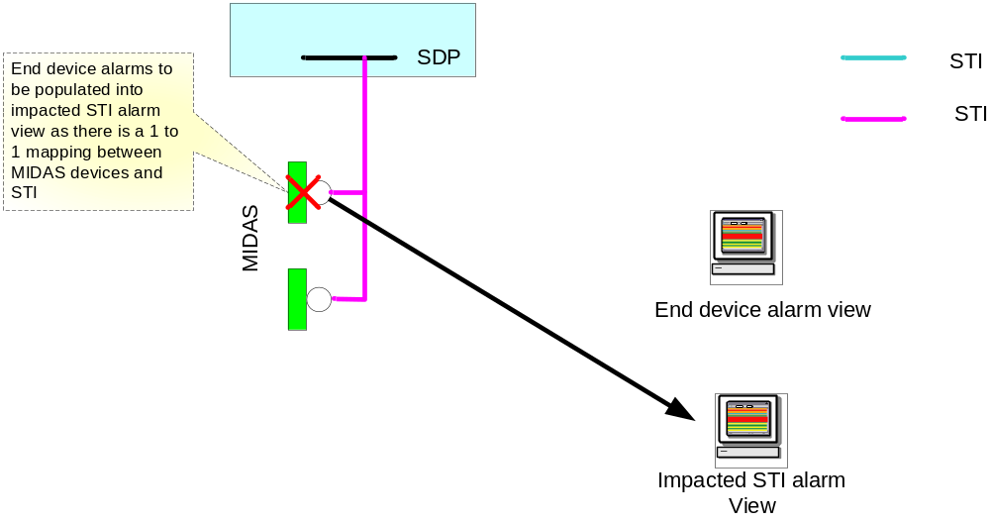
Figure 5 - Handling of MIDAS STI Impacting Alarms

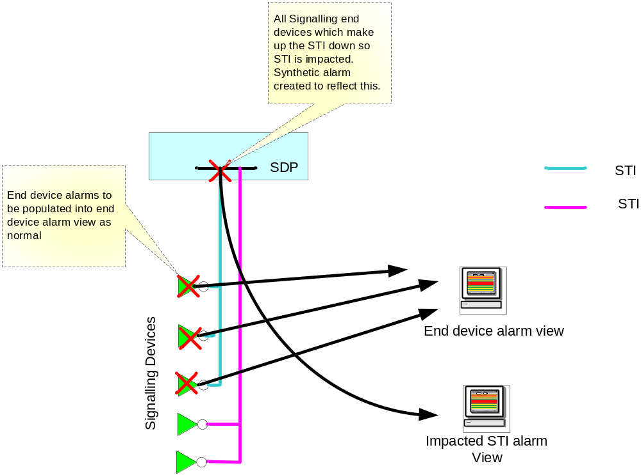
Figure 6 - Handling of SIGNAL STI Impacting Alarms

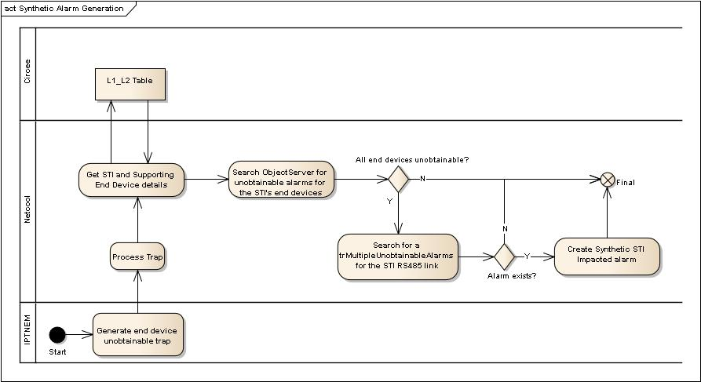
Figure 7 - Synthetic Alarm Generation

WebGUI Configuration
To provide efficient alarm surveillance capability to the NOC, the following bespoke IPT alarm views will be created in WebGUI.
  - A view to display all IPT Outage alarms. This view will be made up of all service affecting alarms as identified in the alarm list and the synthetic STI impacted alarms.

  - A view to display all Signal and MIDAS end device alarms.

  - A view to display all critical IPTNEM and IPT alarms (including LCC related alarms)

  - A view to display all IPT and IPTNEM alarms.

  - A view to display power alarms for devices that are the responsibility of NRTS. These alarms will be identified using the alarm details and the Power Landlord (See Section 3.2.2).

The proposed naming convention is to identify signal devices by including the string 'IPTS' in the system name, and MIDAS devices by including the text 'IPTM. Examples of both are listed below with a full description in section 3.2.2.5.

CATT01HETH01A02IPTM01 - Midas
CATT01HETH01A03IPTS01 – Signal

In addition to the above described views, a tool will be provided to display the underlying alarms that make up a synthetic “STI Impacted” alarm. Through a view, a user will be able to select a synthetic 'STI Impacted' alarm, run the tool and display all end device alarms which are related to the STI failure.

IPTNEM Failover/Configuration
Two IPTNEM instances will be deployed to operate in primary and backup roles. The primary and backup IPTNEM instances will be configured to send traps to both the primary and backup mttrapd probes located in Quinton and Coleshill respectively. Under normal conditions, only one of the IPTNEM instances will send traps northbound to the probes. In the scenario where both IPTNEM instances are unable to communicate, they will both send traps to the probes. This would result in a single fault in the network causing two duplicate traps.

To mitigate against this, the mttrapd probe will be configured to hold an array of values which indicate which IPTNEM server traps have been received from. If the trap which indicates that the communication between the primary and backup IPTNEM servers is received, then a flag will be set in the array to indicate which of the servers has sent the trap.

The table below describes the alarm processing decision to be taken under the different conditions.
Where
IPTNEM.conn.Primary is set to 1 when the trNetConnLost trap is received from the primary IPTNEM (and 0 when it is cleared)
IPTNEM.Conn.Backup is set to 1 when the trNetConnLost trap is received from the backup IPTNEM. (and 0 when it is cleared)

IPTNEM.Conn.Primary | IPTNEM.Conn.Backup | Decision
0 | 0 | Process traps from the primary and discard traps from backup
0 | 1 | Process traps from backup and discard traps from primary
1 | 0 | Process traps from primary and discard traps from backup
1 | 1 | Process traps from primary and discard traps from backup
Table 4 - IPTNEM Failover - Netcool Decision Table
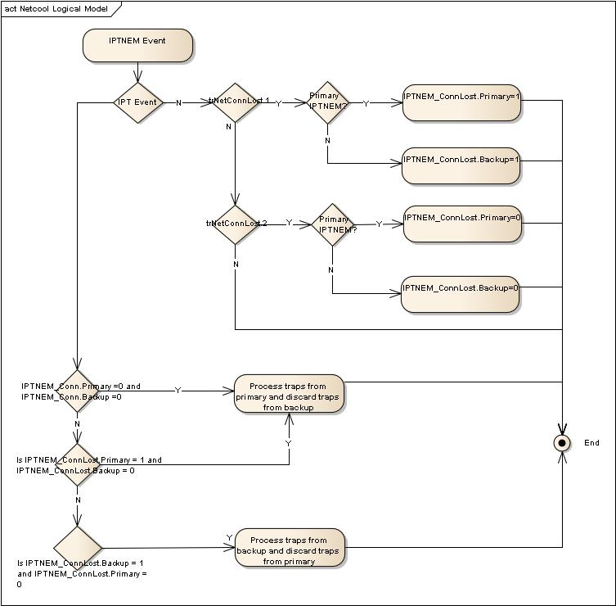

Figure 8 - IPTNEM Failover - Netcool Response

Outage Triggers

There are three Outage conditions required to be automated within phase 2 of the IPT IAMS solution. The Outage Conditions defined below are to be supplemented with additional Outage conditions to be confirmed during the IPT Trial for implementation during the IPT Trial Period and/or within the "IPT Full Solution" (aka WP190 - Phase 3).

Note that the “Trigger” alarms are not intended to be an exhaustive list of alarms required to support the monitoring of the Outage conditions defined below.

The three Outage conditions for IPT IAMS are:

1) IPT Isolated
- Trigger
  - trIPTisolation, trLCCUnobtain, trBootFail or trRestart alarm received from IPTNEM
- Output
  - Automated Trouble Ticket Generated in APM enriched with detail of all STIs Affected

2) Loss of all End Devices on a single RS485 link
- Trigger
  - tr485LinkDown alarm received from IPTNEM
- Output
  - Automated Trouble Ticket Generated in APM enriched with detail of all STIs Affected

3) Multiple End Devices on the same RS485 link simultaneously becoming Unobtainable resulting in the loss of one or more STIs
- Trigger
  - trMultipleUnobtainableAlarm alarm received from IPTNEM and the following condition is met:
  - One or more STIs (that were not previously in an Outage state) are now in a state of Outage as a result of multiple End Devices on the same RS485 link becoming Unobtainable simultaneously (see section 3.2.1.3)
- Output
  - Automated Trouble Ticket Generated in APM enriched with detail of all STIs Affected

4) All End Devices attached to a single SDP becoming Unobtainable resulting in the loss of the one or more STIs
- Trigger
  - trEDUnobtain alarm(s) received from IPTNEM
- Output
  - STI outage presented within the Netcool “view to display all IPT Outage alarms” (ie automated Trouble Tickets NOT generated in the case where there is not also an accompanying trMultipleUnobtainableAlarm) (see section 3.2.1.3)

For the IAMS phase, the following conditions have been identified as outage triggers.
Table
Migration Support
To support the migration of services from the legacy transponders to the IPT Devices, a number of updates will be made to Netcool.
A lookup file populated with details of migrated transponders and their corresponding end devices will be used by the mttrapd probe. Traps from devices appearing in this file will be discarded by the probe. A script will be created to extract details of the migrated transponders from Circee. These details will be used to populate the lookup file which will be used by the probe. The script will be run every 12 hours to refresh the lookup file and capture details of any newly migrated devices.
- The physical migration of the device is completed.
- The Data team update the asset status in Circee to “Removed”
- A scheduled script extracts a list of “Removed” transponders and their associated end devices from Circee.
- The list is used to create a lookup file for the probe.
- The probe is sent a signal to re-read it’s rules and lookup files.

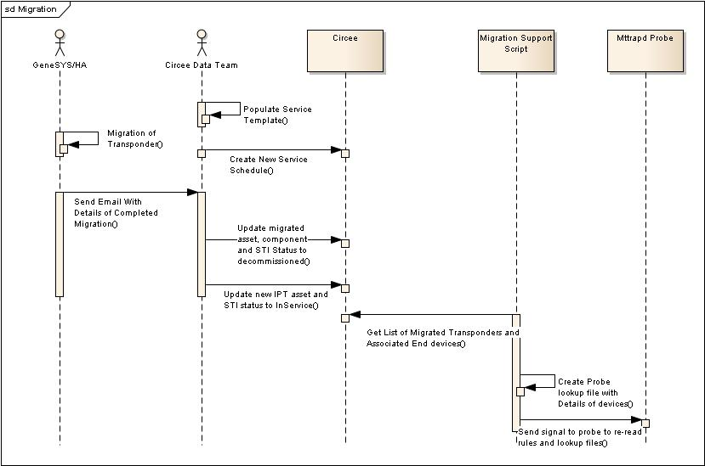
Figure 9 - High Level Migration Sequence

Once the probe’s lookup file has been refreshed, subsequent alarms from the devices in the list will be discarded. With this solution, a window of 12 hours where alarms from migrated device which have not yet been detailed in the lookup file will exist.
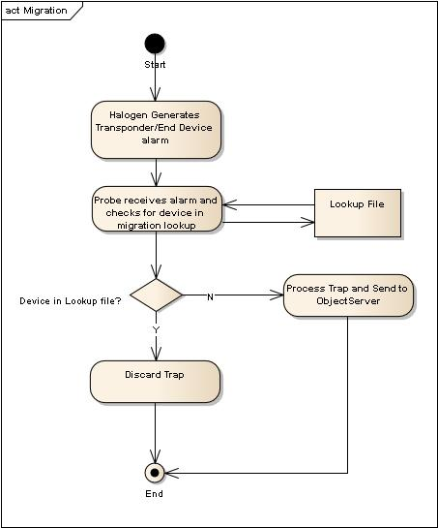
Figure 10 - High Level Processing of Migrated Transponder Alarms

Netcool Parent/Child Correlation - IPT
This will be covered in the full solution phase.

Circee Changes

Circee Requirements Mapping
To support the IPT deployment, the following requirements have been identified. The full list of requirements including deferred and obsolete requirements can be found in section 6.1.

BR ID | BR Description | FR | FR Description
BR427 | The solution will allow a QDT User to create, read, update and delete all the new Civil Infrastructure (e.g. Chambers, Ducts, Equipment Site) required to manage the new network. | Existing  Functionality | Circee allows administrators to create new civil infrastructure types via the GUI.
BR428 | The solution will allow a QDT User to create, read, update and delete all the new Active Telecom Infrastructure (e.g. Network Device and its Components, including ports) required to manage the new network equipment. | FR493 | The asset management system shall, in addition to the standard asset attributes, store the Network Address and Power Landlord (e.g. HA or NRTS)
BR428 |  | FR494 | A new catalogue item shall be created in the Inventory Management system for the IPT Device and corresponding Sub-components as detailed below:  - IPT_Midas_Subrack  IPT_Signals_Subrack  - IPT_PSU_Subrack  - IPT_LPU_Panel  - IPT_LPU  - IPT_ECP_Plug  - IPT_RTC_Battery  - IPT_PSU_Battery
BR428 |  | FR495 | The Inventory Management system shall enable a user to record the following ports for IPT_Midas_Subrack, IPT_Signals_Subrack:  - ECP Port  - ETH Port 1  - ETH Port 2  - RS485 Port 0  - RS485 Port 1  - RS485 Port 2  - RS485 Port 3  - PSU Port  - DryContact Port 1  - DryContact Port 2  - DryContact Port 3  - DryContact Port 4  - RTC Battery Bay 1  - RTC Battery Bay 2  - USB Port
BR428 |  | FR496 | The solution shall have the capability to record the barcode of the IPT device as NOMAD Barcode.
BR429 | The solution will allow a QDT User to create, read, update and delete all the new Passive Infrastructure (e.g. Cables, Fibres, chambers and ducts) required to manage the new network equipment. | Existing Functionality | Circee allows administrative users to create new passive infrastructure types via the GUI
BR430 | The solution will provide the geographic location for all new Infrastructure items where appropriate, and display on the GIS maps as for similar types of asset. | FR659 | The solution will provide the geographic location for all new Infrastructure items where appropriate, and display on the GIS maps as for similar types of asset
BR431 | The solution will have the capability to record the unique physical identifier(s) of an Active Telecom Infrastructure item. | FR496 | The solution shall have the capability to record the barcode of the IPT device as NOMAD Barcode.
BR434 | The solution will support the changes to attributes for one or more IPT Devices ( Bulk changes ) | WP186 and WP180 | The WP186 and WP180 bulk update scripts will be used
BR438 | The solution will allow a QDT User to create, read and update all the new Services to be delivered over the Network. (Permissions to be defined within Functional Requirements). | FR658 | The solution shall allow a user to create Instances of the following Service Types: ST1D ST1E ST2D ST2E
Table 6 - Circee Requirement Coverage

Circee Change Description

To provide the required support for Inventory and Asset Management processes, the following changes are required to be made in Circee.
- The Creation of new active equipment templates
The table below lists the equipment catalogue items and templates which will be required in Circee to support the IPT deployment. Further details of the components required for the template can be found in the accompanying circle template spreadsheet [7].

Equipment Catalogue Items | Catalogue Templates
IPT Midas Sub rack  IPT Signals Sub rack  IPT PSU Sub rack  IPT LPU Panel  IPT LPU  IPT ECP Plug  IPT RTC Battery  IPT PSU Battery  IPT Bat Baya  IPT ETH Port  IPT RS485 Port  IPT PSU Port  IPT Dry Port  IPT USB Port  IPT ECP Port  IPT LPU Port  Modem PSU Port | IPT LPU  IPT LPU Panel  IPT ECP Plug  IPT PSU Sub rack  IPT PSU  IPT MIDAS Sub rack  IPT MIDAS  IPT SIGNAL Sub rack  IPT SIGNAL
Table 7- Catalogue and Templates
- Updates to Circee will be required to support the new service types. The new service types, 1D, 1E, 2D and 2E will be made available as service type options in Circee.
- The IPT related assets physical identifier will be stored in the existing ASSET_BARCODE_NO field in the VIEW_ASSET_NETCOOL table
- A new field will be required to indicate which party has “power landlord” responsibilities for a cabinet. The field will be called “Power Landlord” and be stored against an equipment. This field will be made available for enrichment of alarms in Netcool via the VIEW_ASSET_NETCOOL table. As a result of this, the current device enrichment policy will need to be updated.

- Updates to the topology tables (including L1 and L2 tables) to support the new network topology and infrastructure scenarios. The content and data format will be documented in the low level design documentation.
- Bulk data population for STI, Asset, and Topology data is provided in WP 186 while WP 180 allows the bulk creation and updating of the Topology tables. These capabilities will be updated to support the population of Circee for the assets and services associated with the IPT deployment.
- Bulk migration of existing service types to the new service types. This will be provided
- Provision of a service template which reflects the infrastructure scenario

In Figure 11: Circee Component Design Changes below, the areas where these changes are expected are highlighted in red.

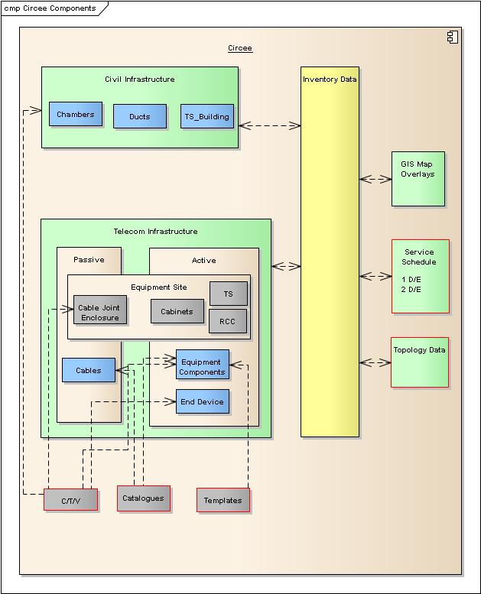

Figure 11: Circee Component Design Changes

Circee Deliverables
The design deliverables from this work package are listed in the table below. While listed on separate rows, these may all be delivered as one patch
- Circee patch to include support for new services
- Circee patch to include support for new IPT devices and sub-components
- Circee patch to include support enrichment support for power landlord field
- Supporting Documentation

Circee Deliverable Verification

The functionality delivered by work packs 190 which have been described need to be tested and verified.
The test cases should cover the following:-

- Full coverage of the requirements detailed in section 3.2.2.1
- Functionality providing support of modelling the new device, sub components and templates as detailed in the accompanying asset template spreadsheet (see [7] ).
- The new service types (1D, 1E, 2D, 2E) must be available for selection from Circee.
- The field to be used to store the power landlord details is made available to the VIEW_ASSET_NETCOOL table
- Non functional tests to ensure that the performance of Circee will not be adversely affected by the support of the IPT deployment.

IPT Device Naming Convention
The devices to be introduced will follow a naming convention which will allow the easy identification of the unique IPT instances in the network. It will follow the general naming convention for the existing new build devices in the network, with variations to allow the identification of IPT devices.

I/F Scenario(s) |  | ATMg/IATMg
Example |  | CATT01HETH01A02IPTM01
Source Tx Station | Source Device Num |  | Destination Tx Station | Destination Device Num | Connected 6850 Span | Connected 6850 Span Num | IPT Identifier | IPT Device Type  M-Midas  S-Signal | IPT Device Num
CATT | 01 |  | HETH | 01 | A | 02 | IPT | M | 01
Table 8 - ATMg & IATMg

I/F Scenario(s) |  | SPCA IPT 1423
Example |  | CATT01HETH010103IPTS01
Source Tx Station | Source Device Num |  | Destination Tx Station | Destination Device Num | Connected 1423 Span | Cabinet # | IPT Identifier | IPT Device Type  M-Midas  S-Signal | IPT Device Num
CATT | 01 |  | HETH | 01 | 01 | 03 | IPT | S | 01
Table 9 - SPCA IPT 1423

I/F Scenarios |  | TCGSA IPT 1423
Example |  | CATT01CATTHETH01A02IPTM01
Source Tx Station | Source Device Num |  | Destination Tx Station | Destination Device Num | Connected 1423 Span | Cabinet # | IPT Identifier | IPT Device Type  M-Midas  S-Signal | IPT Device Num
CATT | 01 |  | CATTHETH | 01 | A | 02 | IPT | M | 01
Table 10 - TCGSA IPT 1423

I/F Scenarios |  | TCGSA IPT 1423 DL
Example |  | CATT01CATTHETH01A03IPTM01
Source Tx Station | Source Device Num |  | Destination Tx Station | Destination Device Num | Connected 1423 Span | Cabinet # | IPT Identifier | IPT Device Type  M-Midas  S-Signal | IPT Device Num
CATT | 01 |  | CATTHETH | 01 | A | 03 | IPT | M | 01
Table 11 - TCGSA IPT 1423 DL

I/F Scenario(s) | SPCA IPT LRS24 and ASMI52
Example | CATTIPTS01
Source Tx Station | IPT Identifier | IPT Device Type  M-Midas  S-Signal | IPT Device Num
CATT | IPT | S | 01
Table 12 - SPCA IPT LRS24 & ASMI52

I/F Scenario(s) |  | SPCA-SPCB IPT 1423 DL and SPCA-Non Adj SPCB 1423 DL
Example |  | BROU01FORT03A01IPTS01
Source Tx Station | Source Device Num | Destination Tx Station | Destination Device Num | Connected 1423 Span | Cabinet # | IPT Identifier | IPT Device Type  M-Midas  S-Signal | IPT Device Num
BROU | 01 | FORT | 01 | A | 01 | IPT | S | 01
Table 13 - SPCA-SPCB IPT 1423 DL & SPCA Non Adj 1423 DL

I/F Scenario | SPCB IPT ASMi52
Example | KENDEIPTS01
Source Tx Station | Span # | IPT Identifier | IPT Device Type  M-Midas  S-Signal | IPT Device Num
KEND | E | IPT | S | 01
Table 14 - SPCB IPT ASMi52

Data model

High Level Data Model

System Logical Data Model – End to End Work Pack View
The following diagram shows the databases resident in all OSS subsystems involved in the solution and the connectivity between them.
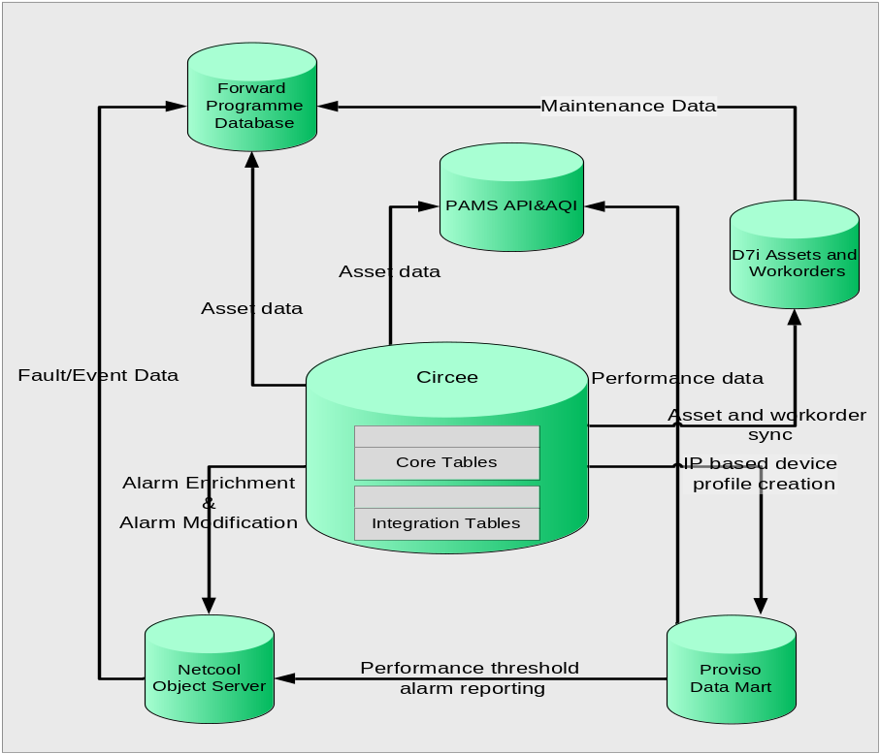

Figure 12: High Level Data Model
The table below lists the data repositories that are shown in the figure above. The table provides a brief description of each and what changes are required as a result of this work package.

OSS Subsystem | Data Model Function | Work Package Changes
Netcool (ObjectServer and Reporter) | This in memory database which is deployed as part of Netcool serves as a repository for alarm and Netcool data. | There will be no change to the ObjectServer data model as part of this work pack.
Circee | The Circee data model stores asset, services and topology data. The database stores data which describes each type of asset and service in the form of catalogue items, templates and the service schedule. | There will be no change to the Circee data model. The appropriate tables will be updated with specific data to enable support for IPT assets and service. The tables to be updated will be detailed in the low level design documentation.
D7i Assets and Work Orders | The D7i database is an Oracle 9i database which holds all the asset and work order information. The asset data is populated by a scheduled job which imports asset data from Circee. This database also stores information regarding all planned maintenance schedules. | The existing data model will be updated with new instance data to support the IPT devices.
PAMS | PAMS stores data collected from a number of sources including Circee, D7i, APM, DMS and Proviso. This data is combined into several metrics using predictive models with the aim of predicting events that could cause failure and outages before. | No changes to the PAMS data model will be required to implement these work packages
Proviso Data Mart | The Proviso DataMart stores data collected and processed by Proviso DataChannel and Proviso DataLoad | Proviso is out of scope for this work package.
Table 15 - Data Repository Changes

Netcool Logical Data Model
There is no change to the Netcool logical data model as a result of this work package.

Circee Logical Data Model
The following VIEW_ASSET_NETCOOL table in Circee will have its schemas amended.

Data Ownership Principle
This section describes the ownership of data for all the OSS subsystems where applicable.
OSS Subsystem | Data Component | Owner | Rules
Netcool (ObjectServer) | Alerts tables | Fluor/HA | The data is received from the Network and stored in the ObjectServer. Once deleted and archived, the data will be stored in the historical alarms database
Netcool (ObjectServer) | Parent/Child Relationship tables | ALU/Fluor | The tables are populated with the relevant data by ALU as part of the OSS SDLC. In principle, Fluor can update the tables as required.
Circee | Asset and Service Templates  Metadata creation for all other objects like cables and civil infrastructure if required will be performed by Fluor post OSS deployment and prior to data population dependent on the presence of this metadata. | ALU | Metadata creation for equipment sites and equipment components will be performed by ALU as part of OSS SDLC. This task will accomplished by designing and developing catalogue items and templates.
Circee | Asset and Service Instance Data | ALU/Fluor | Quinton Data Team will be responsible for data population relating to any moves, adds, and changes to the IPT deployment.
D7i Assets and Work Orders | Asset and Profile Templates | ALU | Metadata creation for equipment sites and equipment components will be performed by ALU as part of OSS SDLC. This task will accomplished by designing and developing the profiles and templates.
Table 16 - Data Ownership

Use Cases
This section details the impacted System Use Cases to deliver the OSS Solution for IPT. As part of the Circee and IAMS phases, only a sub-set of these use cases will be impacted. This sub-set is listed below.
- WP190_UC1 - Manage Inventory Item
- WP190_UC5.1 – Record Alarm
- WP190_UC6 – Display Alarm
- WP190_UC7 – Enrich Alarm
- WP190_UC10 – Define Alarm View

WP190_UC1: Manage Inventory Item

Brief Description
This use case details the activities to view, add, remove and amend Inventory Items (e.g. Civil Infrastructure, Passive & Active Telecom Infrastructure, Service and links between the items) including their status.

Use Case Diagram
The use case diagram below shows the relationships between the use cases and actors
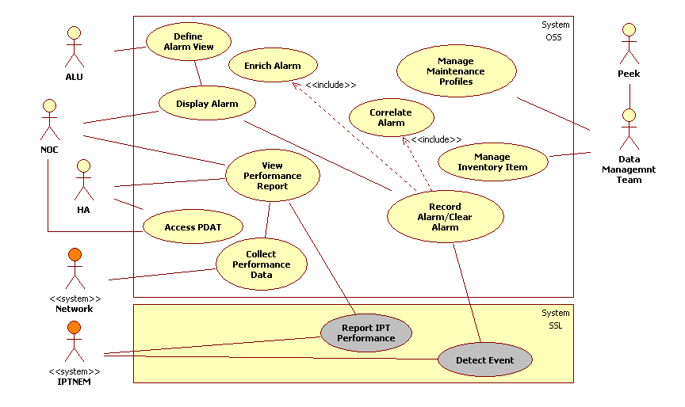

Figure 13: Use Cases

Actors
- Data Management Team

Triggers
- Provisioning tracker received.

Pre Conditions
- The STI has been planned with related assets designed (any CSI(s) will need to have been planned).

Post Conditions
- If appropriate service details will have been corrected.
- STI status will have been set to ‘provisioned’.
- If appropriate, related asset(s) status will have been set to ‘commissioned’.
- If appropriate, related CSI(s) status will have been set to ‘provisioned’.

Basic Flow – Manage Inventory Item
- If the service details are different from those expressed in the design then the service details are corrected as described in Alternative Flow – Correct Service Details.
- The system will allow the user to set the status of the STI to "provisioned".
- The system will allow the user to set the status of an asset(s) to "commissioned".
- The system will allow the user to set the status of the CSI(s) to "provisioned"
- The system will maintain a history of service status changes.
The use case ends.

Alternative Flow – Correct Service Details
- The system will provide graphical representations by displaying network asset information in a layered drawing architecture based on a Geographic Information System (GIS).
  - The system will allow the user access to asset information via the use of an interactive map.
  - The system will provide the user with a means to navigate around the map.
  - The system will allow the user to select an asset or group of assets on the map.
  - The system will allow the user to select a geographical location and the system will then present back to the user the SPC Locality Categorisation.
  - The system will allow the user to transfer the content of the graphical window into another application (e.g. Word).
  - The system will allow the user to control what information is shown on the map.
- If appropriate, asset details are corrected, the use case continues in Alternative Flow – Correct asset details - Step 1.
- If appropriate, service details are corrected, the use case continues in Alternative Flow – Correct service details – Step 1.
- If appropriate assets links are corrected, the use case continues in Alternative Flow – Correct asset links – Step 1.
- The system will maintain a history of asset changes but only limited attributes are stored.
- The use case ends.

Alternative Flow – Correct asset details
- The system will allow for passive telecom infrastructure asset management.
  - The system will allow the user to review the equipment sites associated to a service.
    - The system will allow the user to search for Equipment Sites based on user entered search criteria.
    - The system will provide a facility that highlights on the map the ducts connected to a selected Equipment Site.
  - The system will allow the user to remove equipment sites.
    - The system will allow the user to disconnect an Equipment Site from a duct.
    - The system will allow the user to disconnect one end of the cable from an Equipment Site.
    - The system will allow the user, when no ducts or cables are connected, to remove the record of the Equipment Site.
  - The system will allow the user to modify the equipment site details.
    - The system will allow the user to move an Equipment Site interactively using the map (automatically change its geographic coordinates).
    - The system will allow the user to change an Equipment Site's geographic coordinates.
    - The system will allow the user to rotate an Equipment Site (node).
    - The system will allow the user to change the values of the attributes of an Equipment Site.
  - The system will allow the user to record an Equipment Site.
    - The system will allow the user to record equipment site by using pre-defined templates.
    - The system will allow the user to record an Equipment Site and directly connect it to one duct.
    - The system will allow the user to connect an Equipment Site to a free duct.
    - The system will allow the user to record an Equipment Site independently of any connections.
    - The system will allow the user to connect an Equipment Site to a free cable end.
  - The system will allow the user to review the cables associated to a service.
    - The system will allow the user to search for cables based on user entered search criteria.
    - The system will provide a facility that highlights on the map the cables connected to a node.
  - The system will allow the user to remove the record of the cable.
  - The system will allow the user to change the values of the attributes of a cable.
  - The system will allow the user to record a Cable.
    - The system will allow the user, by use of the map, to record a cable by selecting the Equipment Sites to be connected.
    - The system will allow the user to record a cable independently of connection to any Equipment Sites.
    - The system will allow the user to record cables by using pre-defined templates.
    - The system will allow the user to associate a cable to a duct (Parent (duct)/Child (cable) relationship).
      - The system will provide a function for helping the operator in interactively assigning the cable(s) into the correct duct.
      - The system will indicate to the user for each duct in the trench cable occupancy of the duct as a % ratio.
      - The system will indicate to the user when there are more cables in the duct than the allowable occupancy (based on duct and cable dimensions). This is a warning.
    - The system will allow the user to connect a cable to two Equipment Sites.
- The system will allow for active telecom infrastructure asset management.
  - The system will provide the user with a list of all the links on a motorway that an SDP is located on.
  - The system will allow the user to remove equipment components from and equipment site.
  - The system will allow the user to change the attributes of an equipment component associated to an equipment site.
  - The system will allow the user to add equipment components to an equipment site.
    - The system will allow the user to record an equipment site by using pre-defined templates for equipment components.
- The system will allow for civil infrastructure asset management.
  - The system will allow the user to review the chambers associated to a service.
    - The system will allow the user to search for chambers based on user entered search criteria.
    - The system will provide a facility that highlights on the map the ducts connected to a selected chamber.
  - The system will allow the user to remove Chambers.
    - The system will allow the user to disconnect a chamber from a duct.
    - The system will allow the user, when no ducts are connected, to remove the record of the chamber
  - The system will allow the user to modify the Chamber details.
    - The system will allow the user to move a chamber interactively using the map (automatically change its geographic coordinates).
    - The system will allow the user to change a chamber's geographic coordinates.
    - The system will allow the user to rotate a chamber (node).
    - The system will automatically calculate a new geometry for any connected ducts when a chamber is moved.
    - The system will allow the user to change the values of the attributes of a chamber.
  - The system will allow the user to record a Chamber.
    - The system will allow the user to record a chamber and directly connect it to one duct.
    - The system will allow the user to connect a chamber to a free duct.
    - The system will allow the user to record a chamber independently of any connections.
  - The system will allow the user to review the TS Buildings associated to a service.
    - The system will allow the user to search for TS Buildings based on user entered search criteria.
    - The system will provide a facility that highlights on the map the ducts connected to a selected TS Building.
  - The system will allow the user to remove TS Buildings.
    - The system will allow the user to disconnect a TS Building from a duct.
    - The system will allow the user, when no ducts are connected, to remove the record of the TS Building.
  - The system will allow the user to modify the TS Building details.
    - The system will allow the user to move a TS Building interactively using the map (automatically change its geographic coordinates).
    - The system will allow the user to change a TS Building's geographic coordinates.
    - The system will allow the user to change the values of the attributes of a TS Building.
  - The system will allow the user to record a TS Building.
    - The system will allow the user to record a TS Building and directly connect it to one duct.
    - The system will allow the user to connect a TS Building to a free duct.
    - The system will allow the user to record a TS Building independently of any connections.
  - The system will allow the user to review the ducts associated to a service.
    - The system will allow the user to investigate the composition of a trench.
    - The system will allow the user to search for ducts based on user entered search criteria.
    - The system will provide a facility that highlights on the map the nodes connected to a selected duct.
  - The system will allow the user, when no cables are in the duct, to remove the record of the duct.
  - The system will allow the user to modify the Duct details.
    - The system will allow the user to add/modify/delete a point (or vertex) to the polyline used to display the duct on the map.
  - The system will allow the user to record a duct.
    - The system will allow the user, by use of the map, to record a duct by selecting the two nodes to be connected.
    - The system will allow the user to record a duct independently of connection to any nodes.
    - The system will allow the user to connect a duct to two nodes (this is for the circumstance where the nodes and duct have been recorded but not yet connected).
- The system will set the asset status to ‘planned’ for all assets recorded.
- The system will allow a user to associate a document(s) stored in the document repository (DMS) to an asset.
- If the Service Category is SC10 then the user can record an Aerial Site and Camera Mast Instance (CSI).
- The use case continues in Basic Flow – Manage Inventory Item: Step 3.

Alternative Flow – Correct service details
- The system will allow the user to populate the service details for a Service Shell previously created.
  - The system will allow the user to associate resources with a STI.
  - The system will allow the user to indicate that an asset is a SDP.
    - The system will automatically derive the Marker Post that is associated to an SDP.
    - The system will, when the user is indicating that the asset is an SDP, allow the user to also associate End Devices to the asset.
  - The system will allow the user to modify a STI.
  - The system will allow the user to set the status of the STI to "designed"
    - The system will maintain a history of service status changes.
The use case continues in Basic Flow – Manage Inventory Item: Step 4.

Alternative Flow – Correct asset links
- The system will allow the user to connect two Nodes (specifically between two TSs or between a TS and a SDP) via a TS logical link.
  - The system will, on the recording of a TS logical link, automatically associate all the cables connecting the two Nodes (directly or indirectly connecting) with the TS logical link.
- The system will allow a user to associate a document(s) stored in the document repository (DMS) to a TS Logical Link.
- The use case continues in Basic Flow – Manage Inventory Item: Step 5.

WP190_UC4: Manage Maintenance Profiles

Brief Description
This use case details the addition, removal and amendment of the associated Inspection Profiles and Maintenance for an associated Inventory item.

Use Case Diagram
Refer to Figure 13: Use Cases

Actors
- Data Management Team
- Peek

Triggers
- Category (CTV) and Maintenance Profile details received.

Pre Conditions
- None

Post Conditions
- A Category (CTV) will have been record.
- Maintenance Profiles with the appropriate Activities/Test, Inspections, comments, actions, results and test result values will have been associated to the Category (CTV) recorded.

Basic Flow – Manage Maintenance Profiles
- The system will allow a user to record a Category (CTV).
- The system will allow the user to define Activities/Tests and Inspections.
  - The system will allow the user to define comments, actions and results on Inspections.
  - The system will allow the user to define comments, actions, results and test result values on Activities/Tests.
- The system will allow the user to define groups of Activities/Tests and Inspections into Maintenance Profiles.
- The system will allow the user to assign Maintenance Profiles to one or many CTV Categorisations’.
- If an NRTS Asset is already recorded for the Category (CTV), the use case continues in Alternative Flow – Generate Maintenance Plan – Step 1.
- The use case ends.

Alternative Flow – Generate Maintenance Plan
- The system will automatically associate profiles to assets using an assets CTV. This will be through the creation of Maintenance Plans.
The use case continues in Basic Flow – Manage Maintenance Profiles: Step 6.

WP190_UC5.1: Record Alarm

Brief Description
This use case details the recording of a fault from a device and/or Network Element Manager.

Use Case Diagram
Refer to Figure 13: Use Cases

Actors
- <<system>> IPTNEM

Triggers
- Receipt or detection of a Network Event.

Pre Conditions
- None.

Post Conditions
- An alarm or clearance alarm is recorded in the OSS.
- If appropriate, an alarm will be enriched with supporting information.
- If a clearance alarm is received the related raised alarm will be cleared.
  - Child alarms will be unsuppressed once a parent alarm is cleared
- If appropriate, a Parent/Child alarm relationship will have been created, where the relationship has previously been defined.
- If an alarm meets the predefined criteria for automatic Network Alarm Trouble Ticket generation then a Network Alarm Trouble Ticket is generated.
- The Network Event will be recorded and made available for display.

Basic Flow – Record Alarm
- The system will, on receipt of a Network Event record a ‘Raised’ alarm or ‘Clearance’ alarm, as appropriate.
- The system will tally the occurrences of a duplicate alarm.
- If the Network Event is a clearance event, the use case continues in Alternative Flow – Clear Alarm – Step 1.
- The system will classify all ‘Active’ alarms.
- The system will assign a severity to the alarm.
- => Included Use Case: WP190_UC7: Enrich Alarm.
- => Included Use Case: WP190_UC9: Correlate Alarm.
- If an alarm meets the predefined criteria for automatic Network Alarm Trouble Ticket generation, the use case continues in Alternative Flow – Generate Trouble Ticket - Step 1.
- If appropriate, the system will automatically update the Alarm Status on the corresponding Network Alarm Trouble Ticket.
The use case ends.

Alternative Flow – Clear Alarm
- The system will automatically clear a 'raised' alarm when notified by the IPTNEM that the 'raised' alarm is cleared.
  - The systems will automatically unsupress the related child alarms once a parent alarm is cleared.
- The system will update the fault status associated to an asset as an associated ‘Raised’ alarm moves through its lifecycle. These operation status changes are only for asset with an "In Service" status.
- If appropriate, the system will automatically update the Alarm Status on the corresponding Network Alarm Trouble Ticket.
The use case ends.

Alternative Flow – Generate Trouble Ticket
- The system will update the fault status associated to an asset as an associated ‘Raised’ alarm moves through its lifecycle. These operation status changes are only for asset with an "In Service" status.
- The system will generate a Network Alarm Trouble Ticket (automatically creating an association between the Network Alarm Trouble Ticket and the alarm).
  - The system will set, on creation of a Trouble Ticket, the Trouble Ticket Status to "Unattached".
  - The system will automatically allocate all Trouble Tickets that are generated from a monitored alarm to the NOC Manager.
  - The system will record the date and time that an alarm was registered and the date and time that the associate Network Alarm Trouble Ticket was generated.
  - The system will enrich a Network Alarm Trouble Ticket with asset related information.
  - The system will flag if the Network Alarm Trouble Ticket is related to a Planned Outage.
The use case continues in Basic Flow – Record Alarm: Step 11.

WP190_UC6: Display Alarm

Brief Description
This use case details the activities to display a specified fault/event from the IPTNEM and/or IPT Device to the actor.

Use Case Diagram
Refer to Figure 13: Use Cases

Actors
- NOC

Triggers
- A NOC User requests visibility of IPT Alarms.

Pre Conditions
- An alarm or clearance alarm is recorded in OSS.

Post Conditions
- The appropriate alarms and corresponding attributes will be filtered and displayed.

Basic Flow – Display Alarm
- The system will filter alarms associated with an IPT Device and/or IPTNEM.
- The system will display a list of IPT and/or IPTNEM alarms and their corresponding attributes.

Alternative Flow
None.

WP190_UC7: Enrich Alarm

Brief Description
This use case details the enrichment of a fault with information from the Inventory and other relevant information already contained within a Fault.

Use Case Diagram
Refer to Figure 13: Use Cases

Actors
- <<system>> IPTNEM

Triggers
- Receipt or detection of a Network Event.

Pre Conditions
None.

Post Conditions
- An alarm has been enriched with the appropriate information.

Basic Flow – Enrich Alarm
- The system will enrich alarms with asset related information.
  - The system will enrich an alarm with STI information.
  - The system will flag alarms that are related to planned outages.
  - The system will enrich alarms with the service category affected and the number of effected services.

Alternative Flow
None.

WP190_UC9: Correlate Alarm

Brief Description
This use case details the activities to group requested faults and/or fault types together, hiding those faults agreed as secondary (child), and suppressing any associated Trouble Tickets from being raised, and displaying faults deemed as primary (parent).

Use Case Diagram
Refer to Figure 13: Use Cases

Actors
- <<system>> IPTNEM

Triggers
- Receipt or detection of a Network Event.

Pre Conditions
None.

Post Conditions
- An alarm has been correlated with the appropriate corresponding alarms and displayed or suppressed accordingly.

Basic Flow – Correlate Alarm
- The system will enable automatic alarm correlation. Automatically creating parent/child relationships, where the relationship has previously been defined.

Alternative Flow
None.

WP190_UC10: Define Alarm View

Brief Description
This use case details the activities to select a set of specified faults and/or attributes and group them into one report/view.

Use Case Diagram
Refer to Figure 13: Use Cases

Actors
- ALU

Triggers
- The required views have been agreed with the NOC.

Pre Conditions
None.

Post Conditions
- The appropriate views are available for the selection by the NOC.

Basic Flow – Define Alarm View
- The system will have defined the appropriate alarm attributes for display.
- The system will have defined the appropriate column size.
- The system will have named the view accordingly.

Alternative Flow
None.

WP190_UC11: Report Performance

Brief Description
This use case allows for the collection of performance data and, if appropriate, generates an alarm(s).

Use Case Diagram
Refer to Figure 13: Use Cases

Actors
- <<system>> Network

Triggers
- Network monitoring.

Pre Conditions
- None.

Post Conditions
- Performance data will have been collected.
- If appropriate, an alarm(s) will be generated.

Basic Flow – Report Performance
- The system will collect performance data from the network elements.
  - The system will inventory the element by storing performance data at sub-element group level.
    - The system will collect metrics off vendor specific MIB's
    - The system will collect metrics off common MIB's
  - The system will generate alarms when certain performance threshold violations occur.
- The use case ends.

Alternative Flow
None.

WP190_UC11: View Performance Report

Brief Description
This use case details the activities to view performance reports of the network devices and allows the user to change the granularity of the SNMP data collected for a specific network element.

Use Case Diagram
Refer to Figure 13: Use Cases

Actors
- HA
- NOC

Triggers
- A capacity planning request has been received
- A degradation of service has been detected
- A specific network element has a suspected fault and more detailed performance data needs to be collected.

Pre Conditions
- Performance data collected.

Post Conditions
- Performance data will have been analysed (reports generated).
- The granularity of the SNMP data collected for a specific network element has been changed.

Basic Flow – View Performance Report
- The system will allow the user to view (via reporting) performance metrics and statistics.
  - The system will provide different views for different user groups (HA and NOC).
    - The system will allow the user to constrain the metrics and statistics to be viewed by date.
      - The system will allow the user to view performance metrics and statistics for a specific day, week, quarter, year or 14 month period.
    - The system will allow the user to view performance metrics and statistics by performance threshold violation type.
    - The system will allow the user to view performance metrics and statistics by sub-element group. (Within Service Category)
    - The system will allow the user to view specific performance metrics and statistics (reports) for each sub-element group.
      - The system will allow the user to view performance metrics and statistics in three different ways; Group Summary Table (GST), Resource Summary Table (RST) and Detailed Report.
- The system will allow the user to change the granularity of the SNMP data collected for a specific network element.
- The use case ends.

Alternative Flow
None.

Business Processes
No changes to the existing business processes have been identified.

Data Flow
There are no changes to the inter system data flows.

Interfaces

External Interface Changes
Not applicable

Internal Interface Changes
Not applicable

Section 4: Non Functional Architecture

Non-Functional Architecture
This section describes the changes to the non-functional capability of the system to support Work Package 190 and the new IPT device. Against each non-functional capability, it describes the hardware, software, network (data communications and management) and security elements impacted and the changes to be made to each.

Capacity and Dimensioning
A full and specific planning model cannot be produced at this stage. A performance monitoring and capacity modelling exercise needs to take place beforehand and this in turn needs to be performed on the upgraded Netcool deployment. An IPT specific capacity model will be provided in the IPT full solution phase (phase 3).

Documentation specifying the aforementioned performance monitoring and capacity modelling exercises will be provided as separate deliverables.

For now, this section discusses the aspects of capacity and dimensioning that need to be considered. In addition to this, there will be probe level performance monitoring performed during the live trial.

To ensure that the existing platform will be able to cater for the volume and rate of alarms that will be generated by the IPT devices, a capacity and dimension modelling exercise will be carried out. The specific aims of the exercise are as follows.

To identify the current performance of the platforms with specific focus on
- CPU Utilisation
- Memory utilisation

To identify the current performance of the applications with a specific focus on
- Probe rules processing overhead
- Event rates
- The load on the ObjectServer (automations, client access etc)
- The load on the Netcool Impact to Circee interface

This exercise will be carried out prior to the full solution. Once the current performance statistics have been collected and analysed, the effects of introducing the IPT devices into the network will be assessed. It is anticipated that by this stage, live alarm volumes from the live IPT trial will be available. This will provide an opportunity to base the assessment on live traffic levels.
Of importance for the IPT deployment is the event rates which will be sent to the mttrapd probe. The probe receives events from a number of element managers and this will now include the IPTNEM. The following points have been identified as potentially impacted by the new IPTNEM traps.

- The queue which holds the number of traps as they are received. The probe receives traps independently of trap processing, using an internal queue mechanism. It handles high trap rates and high burst rates using two buffers: one buffer is for all of the sockets that the probe monitors, and the other buffer is an internal queue between the reader and writer sides of the probe (essentially a buffer which controls the frequency at which events are sent to the object server).
The internal buffer which receives traps is by defaut 20000 traps but is currently set to 0 meaning there is no limit. This can potentially cause memory issues on the server in the case of alarm storms.

- The number of traps which can be sent from the IPTNEM. By default, the IPTNEM will support sending up to 2000 traps per minute which is around 33 traps a second (a 30ms wait before transmission between traps). In the worst case, the IPTNEM can send up to 60000 traps a minute which is 1000 traps per second.

The following IBM guidelines for sizing of hosting platforms are by the size of the managed network and the architecture employed, the HA Netcool deployment would fall into the category of a small or standard deployment due to its single tiered nature and relatively small number of resident events ( <50000).

Component | IBM Recommendation | Current Setup | Description
Standard ObjectServer | Cores:2  Memory: 4GB | Cores:4  Memory: 12GB | The ObjectServer is currently co-located with Impact. The ObjectServer being a 32 bit application can only ever use up to 4Gb of memory. In normal conditions, a standard Object Server will use 1-2 CPUS. It is not anticipated that any changes will be required to support the IPT deployment
Probes | Cores:2  Memory: 2GB  (Per Probe) | Cores: 2  Memory: 8GB | Currently, there are 5 probes located in the same container. The current setup already crosses the limit of the IBM recommendations in terms of CPU cores.  In terms of memory usage, the probe will require some memory for storing the rules files on startup and for storing the traps in the queue. Each trap takes up 1500 + 128 bytes of memory. 0.5Mb should be allowed for particularly large rules files. This would mean the probe would require approximately 100Mb of memory. (calculated by(60000 * (1500 + 128))/1048576 + 0.5 Mb).
Table 17 - Server Sizing Guidelines

Initial Recommendations

Currently, the rate of events to the mttrapd probe is estimated to be around 4 events per second. This rate was calculated by querying the reporter database for alarms sent from managers which send SNMP traps over a period of 6 months. The alarms were grouped over by the first occurrence time and an average of the raw alarms (before de-duplication) per minute was calculated. This estimate

The collection of statistics from the ObjectServer and Probes which will be carried out before the full solution will be required to complete the assessment of the solution’s capabilities to cope with this worst case scenario.

The early recommendation will be to deploy a new mttrapd probe on a separate server due to the lack of CPU cores. Memory is not a concern at this point. This recommendation will be confirmed during the full solution design.

Migration
The migration management plan for the legacy transponders to the IPT devices is detailed in [8]. There is an OSS migration element to the overall IPT migration process. The OSS solution design described in section will support the IPT migration process.

In the document [8], a number of steps will be followed to implement the span migration. The migration will be split into 2 phases. Phase 1 will be the site preparation period where the new network is configured and tested to ensure that the migration activities in Phase 2 run as smoothly and quickly as possible. This will require works at the RCC and at the roadside Transmission Cabinets for a number of months. The works during phase 1 are non-intrusive, such that they will not interfere with any live services.

Phase 2 will be the transponder and service migration. This will entail the physical replacement of (and migration of services from) the legacy transponders to the IPT devices in the road side cabinets.

Once the old transponders are removed and replaced with the IPT device, the halogen alarms for removed transponders will no longer be useful. These alarms will still be generated however and Netcool will be required to discard these alarms.

The table below maps the OSS activities required to support the span migration.
Table

Availability
No change.

Back up and Restore
No change.

Data Storage
No change.

Security
No change

Reliability
No change.

Section 5: Impacted Functional Specification Documents

Impacted Functional Specification Documents
The documents listed in the table below are the minimum number to be updated to bring them in line with the design changes as described in this high level design document. Other design, architecture and implementation documentation which need to be updated will be identified at phase 3.

Functional domain | Sub System | Document name
Fault Management | Netcool | GYSRGDSSP0007_R08 PS-DS036-07 FUNCTIONAL SPECIFICATION NETCOOL.doc
Inventory Management | Circee | GYSRGDSSP0009_R08 PS-DS036-05 Functional Specification Circee.doc
Plan and Maintenance Management | D7i | GYSRGDSSP0013_R07 - PS-DS036-09 Functional Specification D7i.doc
Website | Website | GYSRGDSSP0011_ R21 Website FS (PS-DS036-03).doc
Table 19 - List of Required Functional Specification Documents

Section 6: Requirements and Solution Traceability

Requirements and Solution Traceability

Netcool Requirements Mapping
FR Tag | Requirement text | Status | Candidate Use Cases | Phase | Traced-to | DocSection | Compliance Status | Compliance Statement
FR521 | Clears and de-duplication shall continue on the alarm management system after any IPT NEM restart. | Agreed | Correlate Alarm | 190/199 Ph 2 - IAMS | BR458 | 3.2.1.1 | Full
FR522 | Clears and de-duplication shall continue on the alarm management system after any alarm management restart. | Agreed | Correlate Alarm | 190/199 Ph 2 - IAMS | BR458 | 3.2.1.1 | Full
FR558 | The solution will allow users to display all underlying alarms for any synthetic STI failure alarm | Agreed | Correlate Alarm | 190/199 Ph 2 - IAMS | BR452 | 3.2.1.3 | Full
FR560 | The solution will correlate clear and raise alarms for scenarios where the raise alarms have been de-depulicated | Agreed | Correlate Alarm | 190/199 Ph 2 - IAMS |  | 3.2.1.1 | Full
FR561 | The solution will correlate clear and raise alarms for scenarios where the raise alarms have not been de-duplicated | Agreed | Correlate Alarm | 190/199 Ph 2 - IAMS |  | 3.2.1.1 | Full
FR524 | Where all end-devices supporting a single STI are unreachable, the end-device alarms shall be correlated into a single service affecting synthetic alarm. | Proposed | Correlate Alarm | 190/199 Ph 2 - IAMS | BR452(s) | 3.2.1.3 | Full
FR525.1 | A single service affecting synthetic alarm will be enriched with the details and number of affected STI's. | Proposed | Correlate Alarm | 190/199 Ph 2 - IAMS | BR452 | 3.2.1.2, 3.2.1.3 | Full
FR525.2 | All underlying affected end devices/synthetic alarms should be viewable by the Alarm Management system user. | Proposed | Correlate Alarm | 190/199 Ph 2 - IAMS | BR452 | 3.2.1.4 | Full
FR525.3 | These underlying end devices/synthetics wont be sent to the Problem Management system. | Proposed | Correlate Alarm | 190/199 Ph 2 - IAMS | BR452 | 3.2.1.1 | Full
FR527 | A view displaying only IPT alarms shall be created for the NOC. | Proposed | Define Alarm View | 190/199 Ph 2 - IAMS | BR455 | 3.2.1.4 | Full
FR528 | A view shall be created in the fault management system to display IPT power alarms for NRTS owned devices. | Proposed | Define Alarm View | 190/199 Ph 2 - IAMS | BR455 | 3.2.1.4 | Full
FR536 | A view displaying IPT Service Affecting alarms shall be created for the NOC. | Proposed | Define Alarm View | 190/199 Ph 2 - IAMS | BR444, BR455 | 3.2.1.4 | Full
FR531 | The alarm management system shall display the IPT alarms as defined in the alarm list. | Agreed | Display Alarm | 190/199 Ph 2 - IAMS | BR439, BR440, BR455 | 3.2.1.1 | Full
FR562 | A WebGUI view displaying multiple STI affecting alarms shall be created for the NOC. | Agreed | Display Alarm | 190/199 Ph 2 - IAMS |  | 3.2.1.4 | Full
FR563 | A WebGUI view displaying single STI affecting IPT alarms shall be created for the the NOC | Agreed | Display Alarm | 190/199 Ph 2 - IAMS |  | 3.2.1.4 | Full
FR507 | The existing "new build" enrichment process will be applied to the IPT Device alarms. | Agreed | Enrich Alarm | 190/199 Ph 2 - IAMS | BR440 | 3.2.1.2 | Full
FR515 | The alarm management system shall display the impacted STIs and SDP Location for each Service Impacting IPTNEM event. | Agreed | Enrich Alarm | 190/199 Ph 2 - IAMS | BR446(s) | 3.2.1.2 | Full
FR516 | All service affecting alarms from the IPTNEM shall display how many end-devices are affected. | Agreed | Enrich Alarm | 190/199 Ph 2 - IAMS | BR446(s) | 3.2.1.2 | Full
FR519 | Alarms shall be enriched with details showing the power landlord of the cabinet in which the asset is located. | Agreed | Enrich Alarm | 190/199 Ph 2 - IAMS | BR474(s), BR475(s) | 3.2.1.2 | Full
FR555 | For each end device event, the TCP Port will be enriched from a Netcool lookup table | Agreed | Enrich Alarm | 190/199 Ph 2 - IAMS |  | 3.2.1.1 | Full
FR556 | For end device and any synthetic alarms, the solution will enrich the alarm with the source IPT geographic address | Agreed | Enrich Alarm | 190/199 Ph 2 - IAMS |  | 3.2.1.2 | Full
FR501 | The Netcool SNMP Probe shall receive SNMP traps from IPTNEM to report alarms/events that are specific to it and IPT Devices. | Agreed | Record Alarm | 190/199 Ph 2 - IAMS | BR439 | 3.2.1.1 | Full
FR502 | The Netcool SNMP Probe shall map the trap fields to the Netcool event fields. | Agreed | Record Alarm | 190/199 Ph 2 - IAMS | BR439 | 3.2.1.1 | Full
FR503 | The solution shall mark an alarm as requiring NOC action based on information in the alarm list. | Agreed | Record Alarm | 190/199 Ph 2 - IAMS | BR443 | 3.2.1.1 | Full
FR510 | The alarm summary field will contain descriptive information to allow the NOC to understand the effect of the fault. | Agreed | Record Alarm | 190/199 Ph 2 - IAMS | BR440 | 3.2.1.1 | Full
FR512 | The alarm management system shall display, for each IPTNEM event, whether event type is Signals or Midas. | Agreed | Record Alarm | 190/199 Ph 2 - IAMS | BR440 | 3.2.1.1 | Full
FR517 | The solution shall display to the NOC a failure of communication between an IPT and the Local Communications Controller (LCC). | Agreed | Record Alarm | 190/199 Ph 2 - IAMS | BR439 | 3.2.1.1 | Full
FR567 | Duplicate alarms should be discarded irrespective of source | Agreed | Record Alarm | 190/199 Ph 2 - IAMS | BR439 | 3.2.1.5 | Full
FR568 | Unique alarms from either IPTNEM instance will be captured and displayed in the fault management system | Agreed | Record Alarm | 190/199 Ph 2 - IAMS | BR439 | 3.2.1.5 | Full
FR569 | The solution will notify the NOC when there has been a 5 minute gap in receipt of IPT alarms | Agreed | Record Alarm | 190/199 Ph 2 - IAMS | BR439 | 3.2.1.1 | Full
FR666 | There are three Outage conditions required to be automated within the IPT Interim Alarm Monitoring Solution or IAMS (aka WP190 - Phase 2). The Outage Conditions defined below are to be supplemented with additional Outage conditions to be confirmed during the IPT Trial for implementation during the IPT Trial Period and/or within the "IPT Full Solution" (aka WP190 - Phase 3). | Proposed | Correlate Alarm | 190/199 Ph 2 - IAMS | BR444 | Synthetic Alarm Generation3.2.1.3, 3.2.1.6 | Full
FR667 | 1) IPT Isolated  The system shall automatically raise a Trouble Ticket in APM, enriched with detail of all STIs affected, when trIPTisolation, trLCCUnobtain, trBootFail or trReboot alarm received from IPTNEM | Proposed | Correlate Alarm | 190/199 Ph 2 - IAMS | BR444 | 3.2.1.3, 3.2.1.6 | Full
FR668 | 2) Loss of all End Devices on a single RS485 link  The system shall automatically raise a Trouble Ticket in APM, enriched with detail of all STIs affected, when tr485LinkDown alarm received from IPTNEM | Proposed | Correlate Alarm | 190/199 Ph 2 - IAMS | BR444 | Synthetic Alarm Generation3.2.1.3, 3.2.1.6 | Full
FR669 | 3) Multiple End Devices on the same RS485 link simultaneously becoming Unobtainable resulting in the loss of one or more STIs  The system shall automatically raise a Trouble Ticket in APM, enriched with detail of all STIs affected, when trMultipleUnobtainableAlarm alarm received from IPTNEM and the following condition is met:  One or more STIs (that were not previously in an Outage state) are now in a state of Outage as a result of multiple End Devices on the same RS485 link becoming Unobtainable simultaneously. | Proposed | Correlate Alarm | 190/199 Ph 2 - IAMS | BR444 | 3.2.1.3, 3.2.1.6 | Full
FR670 | 4 ) All End Devices attached to a single SDP becoming Unobtainable resulting in the loss of the one or more STIs  The system shall present the STI Outage within a Netcool view to display all IPT Outage alarms when trEDUnobtain alarm(s) received from IPTNEM (ie automated Trouble Tickets NOT generated in the case where there is not also an accompanying trMultipleUnobtainableAlarm). | Proposed | Correlate Alarm | 190/199 Ph 2 - IAMS | BR444 | Synthetic Alarm Generation3.2.1.3, 3.2.1.6 | Full

Circee Requirements Mapping
The rows shaded in grey are obsolete or duplicate requirements. The rows highlighted in yellow are requirements which are still in a “For Review” state. A number of these requirements will be agreed at the low level design stage.
FR Tag | Requirement text | Status | Sub-system | Candidate Use Cases | Traced-to | DocSection | Compliance Status | Compliance Statement
FR494 | A new catalogue item shall be created in the Inventory Management system for the IPT Device and corresponding Sub-components as detailed below:  IPT_Midas_Subrack  IPT_Signals_Subrack  IPT_PSU_Subrack  IPT_LPU_Panel  IPT_LPU  IPT_ECP_Plug  IPT_RTC_Battery  IPT_PSU_Battery | Agreed | Circee | Manage Inventory Item | BR428(s) |  | Full
FR495 | The Inventory Management system shall enable a user to record the following ports for IPT_Midas_Subrack, IPT_Signals_Subrack:  ECP Port  ETH Port 1  ETH Port 2  RS485 Port 0  RS485 Port 1  RS485 Port 2  RS485 Port 3  PSU Port  DryContact Port 1  DryContact Port 2  DryContact Port 3  DryContact Port 4  RTC Battery Bay 1  RTC Battery Bay 2  USB Port | Agreed | Circee | Manage Inventory Item | BR428(s) |  | Full
FR496 | The solution shall have the capability to record the barcode of the IPT device as NOMAD Barcode. | Agreed | Circee | Manage Inventory Item | BR428(s)  BR431 |  | Full
FR658 | The solution shall allow a user to create Instances of the following Service Types:  ST1D  ST1E  ST2D  ST2E | Agreed | Circee | Create Service Types | BR438 |  | Full
FR572 | The Inventory Management system shall be capable of storing <x> number of STI data for IPT related services. | Proposed | Circee | <Non-Functional> |  |  |  | To be assessed as part of full solution
FR573 | The Inventory system shall be capable of storing <x> number of Active Telecom Infrastructure devices for IPT related services. | Proposed | Circee | <Non-Functional> |  |  |  | To be assessed as part of full solution
FR574 | The Inventory Management system shall be capable of storing <x> number of Passive Telecom Infrastructure devices for IPT related services. | Proposed | Circee | <Non-Functional> |  |  |  | To be assessed as part of full solution
FR575 | The Inventory Management system shall be capable of storing <x> number of connections between Active Telecom Infrastructure devices. | Proposed | Circee | <Non-Functional> |  |  |  | To be assessed as part of full solution
FR493 | The asset management system shall, in addition to the standard asset attributes, store the Network Address and Power Landlord (e.g. HA or NRTS) | Agreed | Circee | Manage Inventory Item | BR428(s)
FR491 | The agreed end to end Infrastructure Scenarios shall be documented within the Service Template. | Deferred | Circee | Manage Inventory Item |  |  |  | To be completed as part of the alarm management component of the IAMS solution
FR537 | The agreed Infrastructure Scenarios shall be documented within the Service Template. | Duplicate | Circee | Manage Inventory Item
FR492 | The asset management system shall have the capability to change a service from 8RMD to 1d, 1e, 2d, 2e. | Obsolete | Circee | Manage Inventory Item | BR472 |  |  | Fulfilled as part of WP 186
FR497 | The bulk update scripts shall be amended to support all aspects of the service template requirements including topology. | Obsolete | Circee | Manage Inventory Item |  |  |  | Fulfilled as part of WP180 and WP186
FR498 | New map GIS layer(s) shall be created in the inventory management system to support the deployment of the IPT devices | Obsolete | Circee | Manage Inventory Item |  | n/a | N/A | BR met by existing functionality.
FR557 | The solution shall accurately record the RCC region of each IPT and end device in the inventory management system | Obsolete | Circee | Manage Inventory Item |  |  |  | BR met by existing functionality

Section 7: Low Level Design Part 1

Low Level Design Part 1

Netcool Alarm Formatting
The table below lists some of the key Netcool fields and how they are to be populated.

Netcool Field | Alarm List Column | Specific Rules
Node | Managed Network Object
AlertKey |  | Where the managed object type is IPT, the alert key will be equal to the Managed Network Object.  In all other cases, the sysname should be stripped from the Managed Network Object to obtain the AlertKey.  e.g  trBootFail with managed network object = signals8rmd.  Managed object type is IPT.  AlertKey = signals8rmd  tr485LinkDown with managed network object = signals8rmd/RS485/1  AlertKey = RS485/1
AlertGroup | Alarm Name
Identifier |  | @Identifier=@Node+" "+@AlertKey+"  "+@AlertGroup+" "+@Type+" "+@Agent+"  "+@Manager  Where a reason code is present, the AlarmClass field should be appended
EventId | Source Event_ID
Summary | NETCOOL SUMMARY | A list of appropriate summaries has been detailed against each trap. Where additional information is present in the Additional Information field of the trap, this will be extracted and used to enrich the Summary field
AlarmClass | Alarm Name + Reason Code
Severity | Netcool Equivalent Severity
Table 20 - Key Netcool Field Mapping

Netcool Alarm Enrichment
An enrichment policy based on the existing Netcool Impact new build policy will be created to enrich IPT alarms. Table 21 - IPT Alarm Enrichment Fields below shows the fields expected to be enriched for IPT alarms and the source.

Netcool Field | Source Table | Source Field
SDPLocation | VIEW_ASSET_NETCOOL | SDP_LOCATION
IPAddress | VIEW_ASSET_NETCOOL | IP_ADDRESS
ServiceType | VIEW_ASSET_NETCOOL | SERVICE_TYPE_ID
TSA | VIEW_ASSET_NETCOOL | TS_A
TSB | VIEW_ASSET_NETCOOL | TS_B
RCCArea | VIEW_ASSET_NETCOOL | RCC_AREA_ABBR
AssetElectronicAddress | VIEW_ASSET_NETCOOL | ASSET_ELECTRONIC_ADDRESS
AssetBarCode | VIEW_ASSET_NETCOOL | ASSET_BARCODE_NO
AssetCategory | VIEW_ASSET_NETCOOL | CATEGORY_ABBR
AssetID | VIEW_ASSET_NETCOOL | ASSET_ID
AssetMotorway | VIEW_ASSET_NETCOOL | MOTORWAY_REF
AssetType | VIEW_ASSET_NETCOOL | TYPE_ABBR
AssetVariant | VIEW_ASSET_NETCOOL | VARIANT_ABBR
AssetGeographicAddress | VIEW_ASSET_NETCOOL | ASSET_GEOG_ADDRESS
InServiceStatus | VIEW_ASSET_NETCOOL | ASSET_STATUS_DESC
TPRLocation | VIEW_ASSET_NETCOOL | TPR_LOCATION
STIRef | VIEW_ASSET_STI | STI_REF
STINum | VIEW_ASSET_STI | Calculated Value
STI_HA_Impact | VIEW_ASSET_STI | Calculated from STI_Impact
LocalChain | Reporter_LocalSpan | LOCAL_SPAN
EndDeviceNum | Reporter_LocalSpan | NUMBER_OF_END_DEVICES
PowerLandlord | VIEW_ASSET_NETCOOL | POWER_LANDLORD
Table 21 - IPT Alarm Enrichment Fields
The existing end device enrichment policy will be updated to support the new end device alarms from the IPTNEM. Table 22 - End Device Alarm Enrichment Fields below shows the fields for end device alarms.

Netcool Field | Source Table | Source Field
SDPLocation | VIEW_ASSET_NETCOOL | SDP_LOCATION
ServiceType | VIEW_ASSET_NETCOOL | SERVICE_TYPE_ID
TSA | VIEW_ASSET_NETCOOL | TS_A
TSB | VIEW_ASSET_NETCOOL | TS_B
RCCArea | VIEW_ASSET_NETCOOL | RCC_AREA_ABBR
AssetElectronicAddress | VIEW_ASSET_NETCOOL | ASSET_ELECTRONIC_ADDRESS
AssetBarCode | VIEW_ASSET_NETCOOL | ASSET_BARCODE_NO
AssetCategory | VIEW_ASSET_NETCOOL | CATEGORY_ABBR
AssetID | VIEW_ASSET_NETCOOL | ASSET_ID
AssetMotorway | VIEW_ASSET_NETCOOL | MOTORWAY_REF
AssetType | VIEW_ASSET_NETCOOL | TYPE_ABBR
AssetVariant | VIEW_ASSET_NETCOOL | VARIANT_ABBR
AssetGeographicAddress | VIEW_ASSET_NETCOOL | ASSET_GEOG_ADDRESS
InServiceStatus | VIEW_ASSET_NETCOOL | ASSET_STATUS_DESC
TPRLocation | VIEW_ASSET_NETCOOL | TPR_LOCATION
STIRef | VIEW_END_DEV_STI | STI_REF
STINum | VIEW_END_DEV_STI | Calculated Value
STI_HA_Impact | VIEW_END_DEV_STI | Calculated from STI_Impact
LocalChain | Reporter_LocalSpan | LOCAL_SPAN
EndDeviceNum | Reporter_LocalSpan | NUMBER_OF_END_DEVICES
PowerLandlord  (VarChar 80) | VIEW_ASSET_NETCOOL | POWER_LANDLORD
TCPPort  (Integer) | Lookup File
Table 22 - End Device Alarm Enrichment Fields

End of document

